**Mainframe IMP POINTS**

**Abbrevations**

**ALM –**Application Change Management

**QC** – Quality Control

**OCH** – Oracle Cutomer Hub

**pvt -** Post Verification Testing

**SVI** -Skill Vitality Index

**RBA** – RECORD BYTE ADDRESS

**RDF** - Record-definition Field()

**CIDF** - Control Interval-definition Field

**SMTP** - Simple Mail Transfer Protocol

HPA

RSM Partners - A company

sms – storage management service

sms – short message service

FDR – FAST DUMP RESTORE (FDRCOPY)

**Tools**

**mAINFRAME bASED tOOLS**

1. ENDEAVOUR(en)
2. pANVALET(p)
3. iNFOMAN(I)
4. REMEDY
5. WIP
6. fILEAID
7. QMF
8. SPUFI
9. DCLGEN

**wEB bASED tOOLS**

1. ALM
2. QC

**IMP POINTS**

**->assembler tables**- Huge DB2 tables are converted daily on batch basis into assembler tables for fast access.

We can compare bufferpools with assembler tables both perform the same task of fast access but both are not the same.

**->Tera Data**– Large DATA FOR DATAWAREHOUSING

Datawarehousing (GTW) sent from MSAT(NAB) as Flat SE files was supported by Infosys for nab

->**OBP**(Oracle related) is XML based

->**OSB** converts XML to Cobol

**-> We give Pandd for panvalet datasets**

Eg: //**PANDD1** DD DSN=SDAF.P732083.NAMI.PANV.COBOL.LIBRARY,DISP=SHR

->**RAMTRACE ON**

GIVE displays for each para for debugging

**Mainframe Imp points**

**Q. Can we approximate the maximum space that a sequential dataset can have on a volume?**

**ANS.**

Yes, there’s a geeky way to approximate the maximum space a sequential dataset is allowed to have on a volume. A **Physical Sequential(PS) Dataset can have a maximum of 16 extents on each Volume**.   
  
Maximum SPACE = 1 x PRIMARY + 15 x SECONDARY   
  
For example, if we allocate SPACE as (10,10),   
  
Maximum SPACE = 1 x 10 + 15 x 10 = 160 cylinders.   
  
Thus, the system will try to pick a volume which has 160 cylinder of space.

**SPACE=(CYL,(50,10),RLSE).**  **Request to ReLeaSE** unused space when the output data set gets closed is a good practice improving the overall system performance.

**1.DASD** is another name for a disk drive. Additional synonyms include: disk volume, disk pack, or Head Disk Assembly (HDA).

2. **Space**

Disk space is allocated in units called cylinders, tracks, or blocks.

**Cylinder**

A disk drive contains cylinders. A cylinder is a unit of storage on a count-key-data (CKD) device with a fixed number of tracks.

**Track**

Cylinders contain tracks, which are circular paths on the surface of a disk or diskette on which information is magnetically recorded and from which recorded information is read. Tracks are in count-key-data (CKD) format, which means that each track contains fields that indicate the start of the track and the space used, followed by records containing three fields:

The count field defines the length of the record

The key field contains optional accounting information

The data field contains the user data

**Record**

Tracks contain records. A record is some number of bytes containing data. The record is the basic unit of information used by a program running on z/OS.

Records have a logical record length (abbreviated as LRECL); different types of DASD impose different maximum lengths for records.

Records are either fixed length or variable length in a given data set. Traditional z/OS data sets have one of five record formats (abbreviated as RECFM): Fixed (F), fixed blocked (FB), variable (V), variable blocked (VB), or undefined (U).

**Blocks**

Records can be grouped into data blocks, which are the units of recording on disk. Blocking makes processing more efficient because z/OS can access an entire block at once instead of reading or writing records individually.

Block size (abbreviated as BLKSIZE) is the physical block size written on the disk for fixed (F) and fixed block (FB) records. For variable and undefined (V, VB, and U) records, block size is the maximum physical block size that can be used for the data set.

**Extents**

Space for a disk data set is assigned in primary and secondary extents. An extent is a contiguous number of disk drive tracks, cylinders, or blocks. Data sets can increase in extents as they grow. As with blocking, the use of extents is more efficient because reading or writing contiguous tracks is faster than reading or writing data that is scattered over the disk.

**Volume**

The term volume is often used to refer to a disk.

**Volume serial**

The six-character name of a disk or tape volume, such as TEST01.

**Device type**

A model or type of disk device, such as 3390.

**Organization**

The method of processing a data set, such as sequential.

**TSO COMMANDS**

-> While debugging the code we can put locators inplace of line numbers like **.a** and in future we can go to that line number by giving **L a**

**-> Hi COB** to check syntax for cobol

->**Cols**for line numbers

->**TSO RACF -** to give access SPOOL permissions

OPTION ===> 3

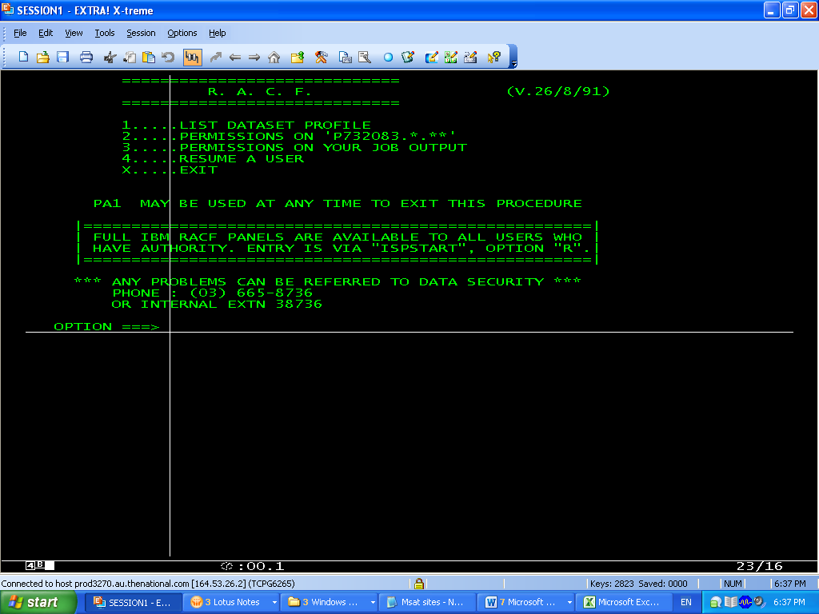

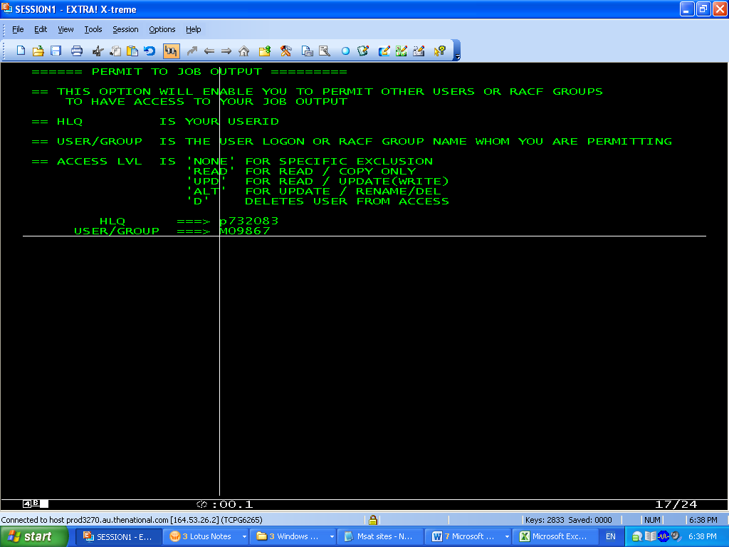

**ENDEAVOUR**

->To check for changes in the code do **‘F %’**

**pANVALET(p)**

->To check for changes in the code do **‘F CL*’**

**iNFOMAN(I)**

->We give change number in the Infoman to find all the detailed information about the change

**REMEDY**

->

**WIP**

->we genetate Wit librry before comparing the codes

SDAF.PP40223.WIP.LIBRARY

->Compare utlity we check the library and search for **‘F %’**to find modifications(insertions or deletions) in the code

SDAF.PP40223.WIP.LIBRARY

**fILEAID**

->**fad –** To access file aid for DB2 tables

FAD:1(Browse)

**Creator**  :PD

**Table Name** :*

**Selection Criteria usage : N** direcly displays data when table is selceted

**: T** displays table structure upon **PF6**displays data

Press enter to find Table names

EG:

AC_ROLE_IN_SRVC

**AC_ROLE_TYPE**

AC_TYPE

AF_RPT

AF_RPT_CYCL

AF_RPT_EVENT_TYPE

AKF_BASE_RATES

AKF_RATE_CODE

AKF_SMRY_CNT_GRP

AKF_SMRY_LINE

AKF_SMRY_TRN_MODE

AKF_SUMMARY_TXT

AKF_SUMMARY_TYPE

**QMF**

->To enter into QMF **start D:3(QMF)**

We can direcly give sql queries here by pressing **PF6(Query)**

Please note that **table name must be prefixed with creator**

After entering the query say **SELECT * FROM PD.AC_ROLE_TYPE**

We have to give the command **run**

